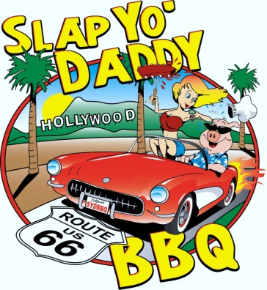
SLAP YO’ DADDY BBQ
3-Meat Mock Competition Class
Registration Form

Name: Team Name:

You are a (check all that applies): Beginner Intermediate Advanced

Competitor KCBS Certified BBQ Judge

Street Address:

City: State: Zip:

*Email address: Phone:

Cost is $75.00 per team. Plus customized trophies

Registration requests are processed on a first come first serve basis. Once your registration and check has been received and a spot is still open, we will send out an email to confirm your spot. Checks are deposited 2 weeks before class or when you are confirmed, whichever is less.

Class fee will include your space for Saturday, short competition lesson by instructor, and trophies. Water will be available. Electricity will not be available. All trash must be carried out. Disposal of ash, grey water, and grease will be determined soon (see website for latest updates). Your entry fee will cover all 3 meat categories (chicken, ribs, and tri-tip). Space is limited to 18 teams. Teams will provide all necessary meats and supplies for contest. Team check-in starts at 5:30 AM on Saturday morning.

Please contact Donna Fong for any special needs or setup. (510-390-7447) or butchersdaughter@hotmail.com

SITE PREFERENCE (select one)

20x20 site RV site (no hookups)

Class location: Maurice Car'rie Winery, 34225 Rancho California Rd, Temecula, CA 92591

Please make check payable to Harry Soo

Mail signed registration form and payment to:

Mimi Castillo
1113 Catlin St. #B
Simi Valley, CA 93065

The student agrees to adhere to all rules and regulations given by Harry Soo, Slap Yo’ Daddy BBQ (SYD BBQ). Student agrees to hold (SYD BBQ) harmless for any injury or damages which may occur during the class. In consideration of being permitted to participate in any way in the cooking class, I, for myself, my heirs, personal representatives, or assigns, do hereby release, waive, discharge, and covenant not to sue the instructor and agents from liability from any and all claims including the negligence of instructor and agents, resulting in personal injury, accidents or illnesses (including death), and property loss arising from, but not limited to, participation in the cooking class. The student further agrees to hold any and all information presented as a trade secret and will not publish, relay, or otherwise communicate in any form any of said information in any manner for any cause. The use of any video recording device is strictly prohibited except by SYD BBQ. Cameras for shooting still pictures are permitted. The student agrees that (SYD BBQ) may use any photos or video taken at the class for any lawful promotional reasons it deems necessary. By signing the registration form the student agrees to these terms and conditions set therein.

Signature Date:

Comments or questions: class@slapyodaddybbq.com or call 805-587-7624

